LAB MANUAL
Deep Learning for Robotics
S.No | Date | Experiment | Page no
 |  | Building Differential Drive Robot Virtually
 |  | Fundamentals Of Arduino
 |  | Building A Omni directional Robot
 |  | Build A Simple Neural Network
 |  | Data Visualization using inbuilt data set in Keras
 |  | Build A churn modelling using Multi layered Neural network.
 |  | Optimization Using Stochastic Gradient Descent Algorithm
 |  | Build an image recognition system using CNN
 |  | Stock Price Prediction Using LSTM
 |  | Neural Style Transfer Using Gan

Experiment 1: Building And Programming of Teleoperation Differential Drive Robot
Virtually
- Aim:
Construct a differential robot using primitive shapes and program it to demonstrate fundamental movements
- Description:
Differential Drive Robot: A differential drive robot is a type of mobile robot that moves by varying the speeds of its two drive wheels. Here's how it works:
Drive System: The robot is typically driven by two wheels mounted on either side of the robot's body. Each wheel can be independently controlled, allowing the robot to move forward, backward, or turn in place.
Differential Steering: To move forward, both wheels rotate in the same direction at the same speed. To turn, the wheels rotate in opposite directions, with the wheel on the side of the turn moving slower than the wheel on the other side.
Speed Control: By controlling the speed of each wheel independently, the robot can achieve different types of movements, such as straight-line motion, curves, and spins.
Limitations: Differential drive robots can be prone to slipping, especially when turning on uneven or slippery surfaces. This can affect the accuracy of their movements.
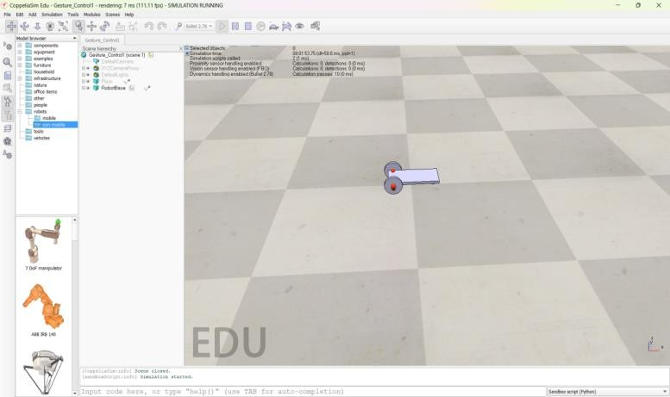
Differential drive robots are commonly used in robotics education and research due to their simplicity and effectiveness in a wide range of applications. They are often used in tasks such as exploration, mapping, and surveillance.

Image Source - Differential Drive Robot using primitive shapes in Coppeliasim
- Algorithm:
- Import the required primitive shapes of size needed for the robot
- Add the revolute joint to the design as these are going to act as motors for the robot
- Build and position the caster wheel along with a force send
- Provide parent-child relationship to the components we have added
- Create a script for the built robot
- Open the script and initialize the motors
- Build the logic for the key press.
- Program it in LUA for the basic movements of the robot
- Play and check the simulation

Code Implementation:
function sysCall_init()

leftFront = sim.getObject('/Revolute_joint[0]')
rightFront = sim.getObject('/Revolute_joint[1]')
leftRear = sim.getObject('/Revolute_joint[2]')
rightRear = sim.getObject('/Revolute_joint[3]')

forwardSpeed = 4
turnSpeed = 2

end

function setWheelSpeed(leftSpeed, rightSpeed)

sim.setJointTargetVelocity(leftFront, leftSpeed)
sim.setJointTargetVelocity(leftRear, leftSpeed)

sim.setJointTargetVelocity(rightFront, rightSpeed)
sim.setJointTargetVelocity(rightRear, rightSpeed)

end

function sysCall_actuation()

-- Move forward
setWheelSpeed(forwardSpeed, forwardSpeed)

-- Turn left:
-- setWheelSpeed(-turnSpeed, turnSpeed)

-- Turn right:
-- setWheelSpeed(turnSpeed, -turnSpeed)

end

Experiment 2: Fundamentals Of Arduino

- Aim: To grasp the fundamentals of Arduino, program it using the IDE, and upload the code to verify its functionality.

- Requirements:
- Arduino UNO Board
- USB Cable
- Arduino IDE Software

- Explanation
Arduino: Arduino is an open-source electronics platform based on easy-to-use hardware and software. Here are its key fundamentals:
Microcontroller: Arduino boards are equipped with microcontrollers (usually from the Atmel AVR or ARM Cortex families) that act as the brains of the board. These microcontrollers can be programmed to perform a variety of tasks.
Arduino IDE: The Arduino Integrated Development Environment (IDE) is a software application used to write and upload code to the Arduino board. It provides a simple interface for writing code in the Arduino programming language, which is based on C and C++.
Input/Output Pins: Arduino boards have a number of digital and analog input/output pins that can be used to interface with external sensors, actuators, and other electronic components. These pins can be configured as inputs or outputs in software.
Power Supply: Arduino boards can be powered via USB, a DC power jack, or an external power source. They typically operate at 5V, but some boards also support 3.3V operation.
Expansion Shields: Arduino boards can be expanded using shields, which are additional circuit boards that plug into the main Arduino board. Shields can add functionality such as wireless communication, motor control, and sensor interfaces. Programming Language: Arduino uses its own programming language, which is similar to C and C++. It provides a set of libraries and functions that simplify common tasks such as reading analog sensors, controlling servos, and communicating over serial.

Overall, Arduino is a versatile platform that can be used for a wide range of projects, from simple blinking LED experiments to complex robotics and automation applications. Its ease of use, affordability, and large ecosystem of compatible hardware and software make it a popular choice for hobbyists, students, and professionals alike.

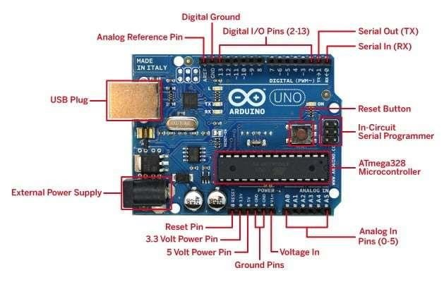

Image Source - https://robosynckits.in/wp-content/uploads/2020/12/arduino-uno-r3pic3.j
- Steps
- Download and install the Arduino IDE
- Get a new file
- Initialize the in-built LED
- Program the logic such that it blinks for one second
- Connect the Arduino UNO board to the computer
- Select the appropriate board and its corresponding port
- Upload the program
- Once upload is complete the in-built LED will blink

- Code Implementation:
void setup()
{
pinMode(LED_BUILTIN, OUTPUT);
}

void loop()
{
digitalWrite(LED_BUILTIN, HIGH);
delay(1000);

digitalWrite(LED_BUILTIN, LOW);
delay(1000);
}

- Result:
Therefore, the fundamental aspects of Arduino have been learned, and a basic program to blink the built-in LED has been developed, tested, and uploaded to the board for visualization.
Experiment: 3 Building A Omni directional Robot

- Aim:
To construct and evaluate a wireless robot control system using Bluetooth.
- Requirements:
- Arduino UNO Board
- USB Cable
- DC Motors
- Motor Driver
- LiPo Battery
- Jumper Wires
- Robot Chassis
- Required Hardware
- Arduino IDE Software

- Connection Diagram
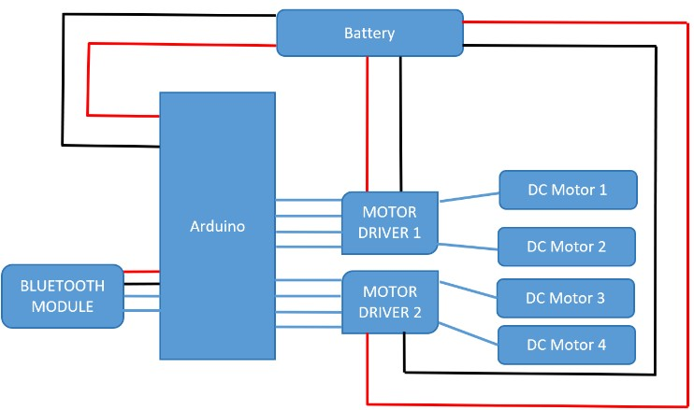
Steps
- Build the robot using robot chassis and hardware
- Place the electronic components and wire them using jumper wires
- Get a new file
- Initialize the motors and serial begin the communication module
- Program the logic such that Omni directional motion to be executed
- Connect the Arduino UNO board to the computer
- Select the appropriate board and its corresponding port
- Upload the program
- Once uploaded, connect the battery to turn on
- Check for the Correct Execution.

- Code Implementation:

// LEFT WHEEL CONNECTIONS
int inl4 = 7;
int inl3 = 4;
int inl2 = 3;
int inl1 = 2;

// RIGHT WHEEL CONNECTIONS
int inr4 = 13;
int inr3 = 12;
int inr2 = 10;
int inr1 = 8;

void setup()
{
Serial.begin(9600);

// Set all motor control pins as OUTPUT
pinMode(inl4, OUTPUT);
pinMode(inl3, OUTPUT);
pinMode(inl2, OUTPUT);
pinMode(inl1, OUTPUT);

pinMode(inr4, OUTPUT);
pinMode(inr3, OUTPUT);
pinMode(inr2, OUTPUT);
pinMode(inr1, OUTPUT);

// Initial state - Motors OFF
digitalWrite(inl4, LOW);
digitalWrite(inl3, LOW);
digitalWrite(inl2, LOW);
digitalWrite(inl1, LOW);

digitalWrite(inr4, LOW);
digitalWrite(inr3, LOW);
digitalWrite(inr2, LOW);
digitalWrite(inr1, LOW);
}

void loop()
{
// FORWARD
Serial.println(F("FORWARD"));

digitalWrite(inl4, HIGH);
digitalWrite(inl3, LOW);
digitalWrite(inl2, HIGH);
digitalWrite(inl1, LOW);

digitalWrite(inr4, HIGH);
digitalWrite(inr3, LOW);
digitalWrite(inr2, HIGH);
digitalWrite(inr1, LOW);

delay(5000);

// BACKWARD
Serial.println(F("BACKWARD"));

digitalWrite(inl4, LOW);
digitalWrite(inl3, HIGH);
digitalWrite(inl2, LOW);
digitalWrite(inl1, HIGH);

digitalWrite(inr4, LOW);
digitalWrite(inr3, HIGH);
digitalWrite(inr2, LOW);
digitalWrite(inr1, HIGH);

delay(5000);

// SIDE RIGHT
Serial.println(F("SIDE RIGHT"));

digitalWrite(inl4, HIGH);
digitalWrite(inl3, LOW);
digitalWrite(inl2, LOW);
digitalWrite(inl1, HIGH);

digitalWrite(inr4, LOW);
digitalWrite(inr3, HIGH);
digitalWrite(inr2, HIGH);
digitalWrite(inr1, LOW);

delay(5000);

// SIDE LEFT
Serial.println(F("SIDE LEFT"));

digitalWrite(inl4, LOW);
digitalWrite(inl3, HIGH);
digitalWrite(inl2, HIGH);
digitalWrite(inl1, LOW);

digitalWrite(inr4, HIGH);
digitalWrite(inr3, LOW);
digitalWrite(inr2, LOW);
digitalWrite(inr1, HIGH);

delay(5000);

// RIGHT TURN
Serial.println(F("RIGHT"));

digitalWrite(inl4, HIGH);
digitalWrite(inl3, LOW);
digitalWrite(inl2, HIGH);
digitalWrite(inl1, LOW);

digitalWrite(inr4, LOW);
digitalWrite(inr3, LOW);
digitalWrite(inr2, LOW);
digitalWrite(inr1, LOW);

delay(5000);

// LEFT TURN
Serial.println(F("LEFT"));

digitalWrite(inl4, LOW);
digitalWrite(inl3, LOW);
digitalWrite(inl2, LOW);
digitalWrite(inl1, LOW);

digitalWrite(inr4, HIGH);
digitalWrite(inr3, LOW);
digitalWrite(inr2, HIGH);
digitalWrite(inr1, LOW);

delay(5000);

- Result:
Therefore, the robot is wireless controlled via Bluetooth, and a set of options are executed by sending corresponding numbers through a mobile app.
Experiment No:4 Build A Simple Neural Network

- Aim:
Constructing a simple neural network in TensorFlow to execute logistic regression and categorize the output.
- Description:
Logistic regression is a statistical method used for binary classification tasks, where the goal is to predict the probability that an instance belongs to a particular class (usually denoted as class 1). Here's an explanation of logistic regression and how it's built in TensorFlow 2
- Logistic Regression:

- Model:
- In logistic regression, the output of the model is obtained by applying the logistic function (also known as the sigmoid function) to a linear combination of the input features:
= (w1x1 + w2x2 + ... + wnxn + b)
- Here, y represents the predicted probability that the instance belongs to class 1, x1, x2, ..., xn are the input features, w1, w2, ..., wn are the weights, b is the bias term, and si is the sigmoid function.
- Sigmoid Function:
The sigmoid function transforms the linear combination of inputs into a value between 0 and 1, representing the probability of belonging to class 1: sigma(z) = frac11 + e^{-z}
- Training:

During training, the model learns the optimal values of weights w and bias b by minimizing a loss function (e.g., binary cross-entropy loss) using optimization algorithms like gradient descent.
- Prediction:
Once trained, the model can predict the probability of belonging to class 1 for new instances by passing their features through the trained logistic regression model.
- Algorithm
- Import necessary libraries and the dataset
- Create a TensorFlow sequential model and a sigmoid activation function
- Compile the model with appropriate optimizer and a suitable loss function
- Train the model using fit method y providing input and target
- Specify the number of epochs for training
- Predict using new data and evaluate the model’s performance

- Code Implementation:
pip install tensorflow
Show hidden output
import
tensorflow
as
tf
import
numpy
as
np
import
pandas
as
pd
import
matplotlib.pyplot
as
plt
import
seaborn
as
sns
from
tensorflow
import
keras
pip install scikit-learn
Show hidden output
from
sklearn.datasets
import
load_iris
from
sklearn.model_selection
import
train_test_split
from
sklearn.preprocessing
import
StandardScaler
Iris_data=load_iris
()
Iris_data
Show hidden output
Iris_data
[
"target_names"
]
array(['setosa', 'versicolor', 'virginica'], dtype='<U10')
Iris_data
[
"feature_names"
]
[
'sepal length (cm)',

'sepal width (cm)',

'petal length (cm)',

'petal width (cm)']
x=Iris_data
[
"data"
]
x.shape
(150
,
4)
y=Iris_data
[
"target"
]
y.shape
(150,)
Data_Frame=pd.DataFrame
(
data=np.concatenate
((
x
,
y.reshape
(
-1
,
1
))
,
axis=
1
)
,
columns=
[
'sepal length'
,
'sepal width'
,
'petal length
Data_Frame
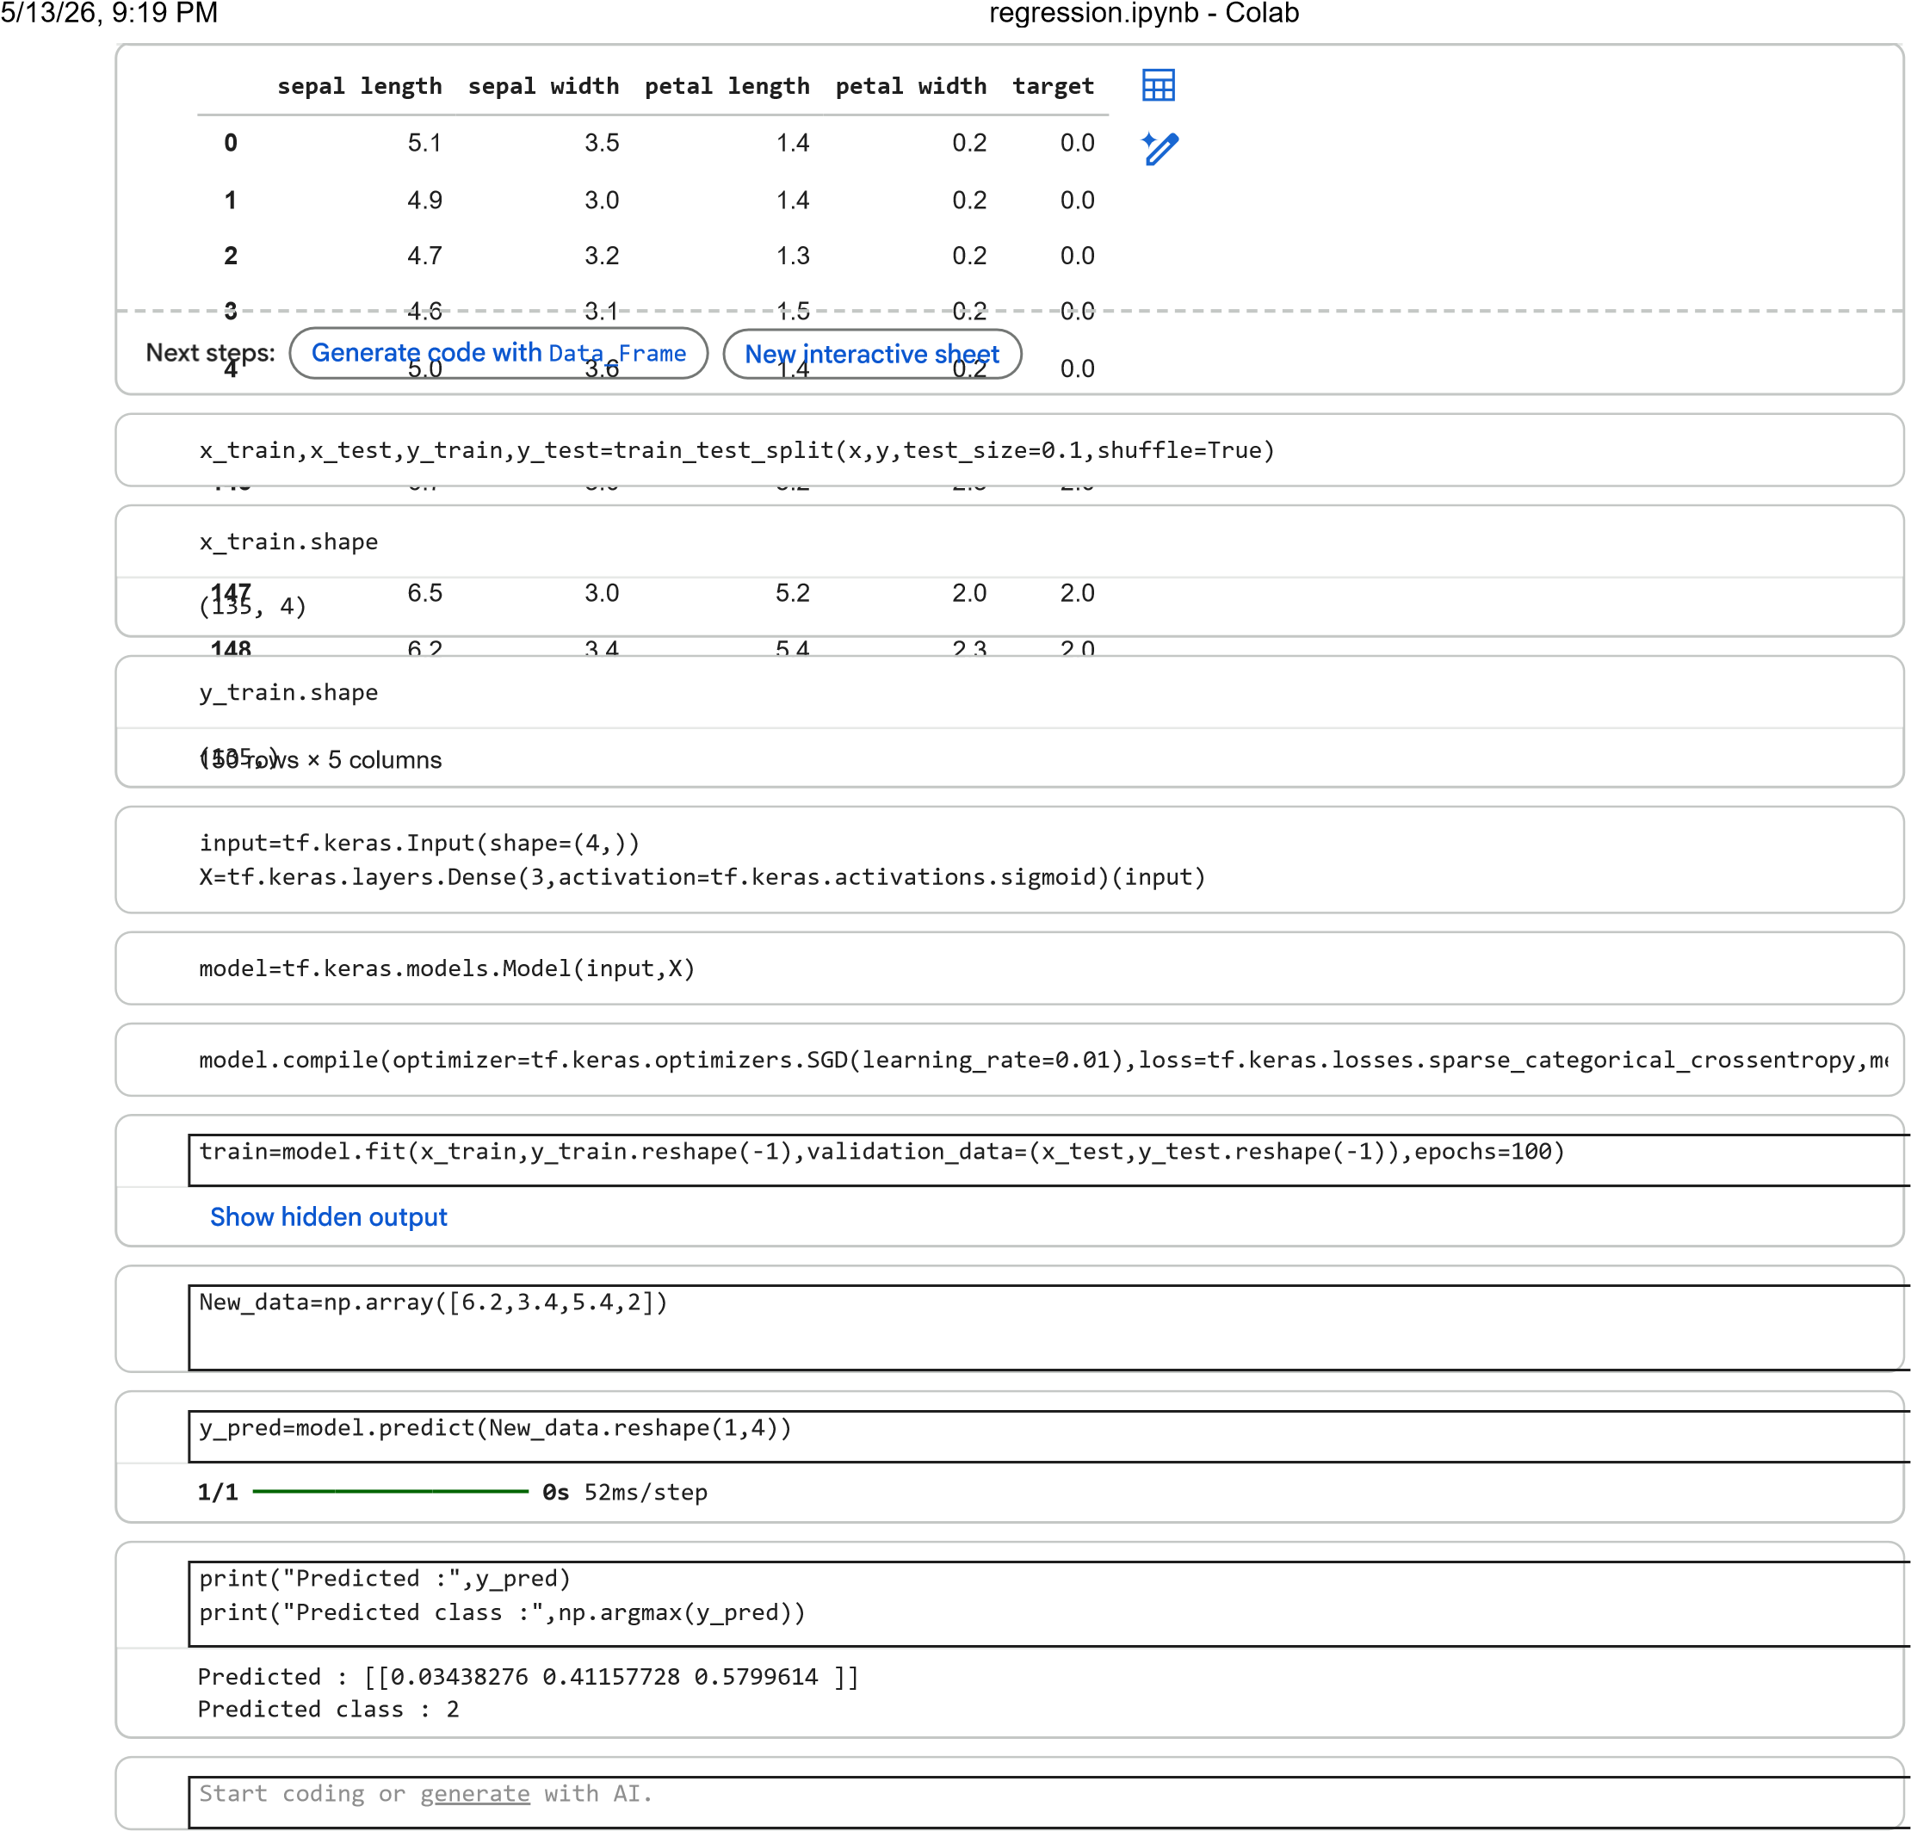

- Result:
Thus, utilizing TensorFlow, a simple neural network is constructed to implement logistic regression with a dataset and classify the output.
Experiment No: 5 Data Visualization using inbuilt data set in Keras

- Aim:
To visualize tensor data using Keras.
- Algorithm
- Import all necessary libraries
- Load the inbuilt datasets
- Visualize the data using plots
- Display the output results

- Code Implementation:

- Result:
Hence, the tensor data in keras API was Imported and Visualized using plots.
Experiment No: 6 Build A Churn model using Multi-Layer Perceptron

- Aim:
To build a Multi layered perceptron model in python using TensorFlow 2
- Explanation:

Multi-Layer Perceptron
A multi-layer perceptron (MLP) is a type of feedforward artificial neural network that consists of multiple layers of nodes, each connected to the next in a sequential manner. MLPs are used for supervised learning tasks, including classification and regression.
- Input Layer: The input layer receives the features of the input data.
- Hidden Layers: One or more hidden layers process the input data through a series of weighted connections and activation functions. Each node in a hidden layer takes the weighted sum of its inputs, applies an activation function (such as ReLU or sigmoid), and passes the result to the next layer.
- Output Layer: The output layer produces the final predictions or outputs of the model. The number of nodes in the output layer depends on the task (e.g., binary classification, multi-class classification, regression).
- Activation Functions: Activation functions introduce non-linearity into the model, allowing it to learn complex patterns in the data. Common activation functions include ReLU, sigmoid, and tanh.
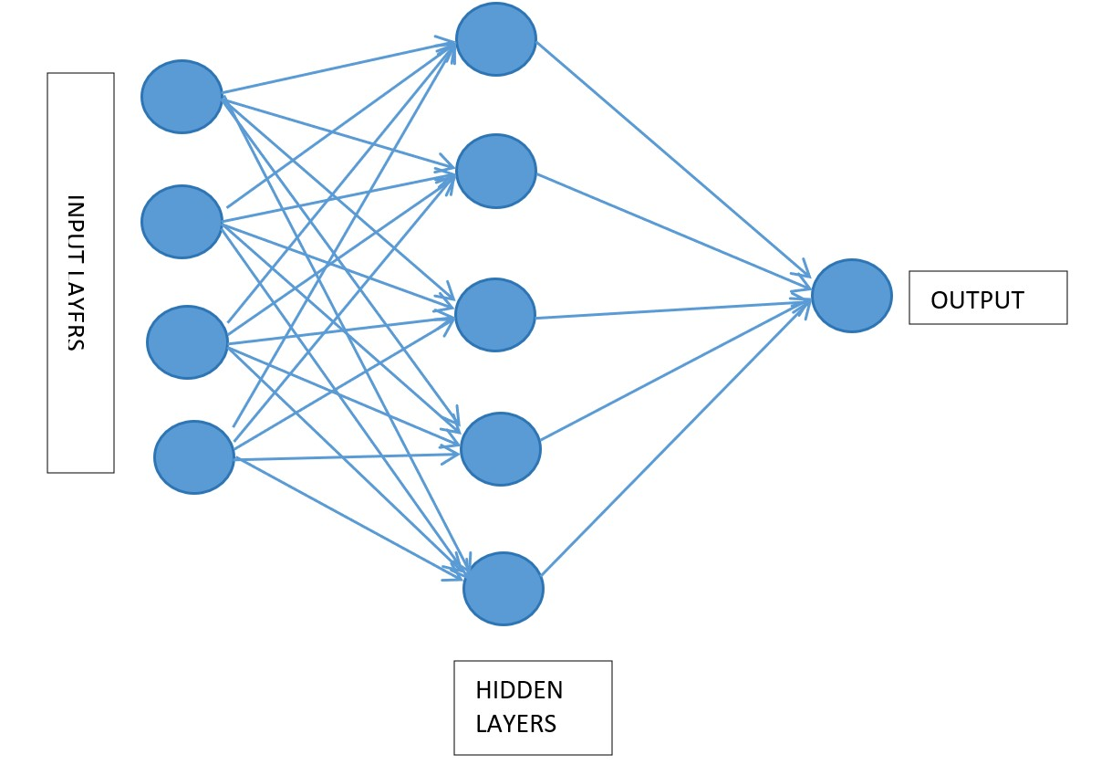
- Training: MLPs are trained using backpropagation, where the error between the predicted output and the actual output is calculated (using a loss function) and propagated back through the network to update the weights using an optimization algorithm (such as SGD or Adam).
- Algorithm:
- Import dataset
- Create the network architecture
- Build and compile the neural network
- Fit the values and train with set number of epochs and in batch.
- Predict the outcome with new values

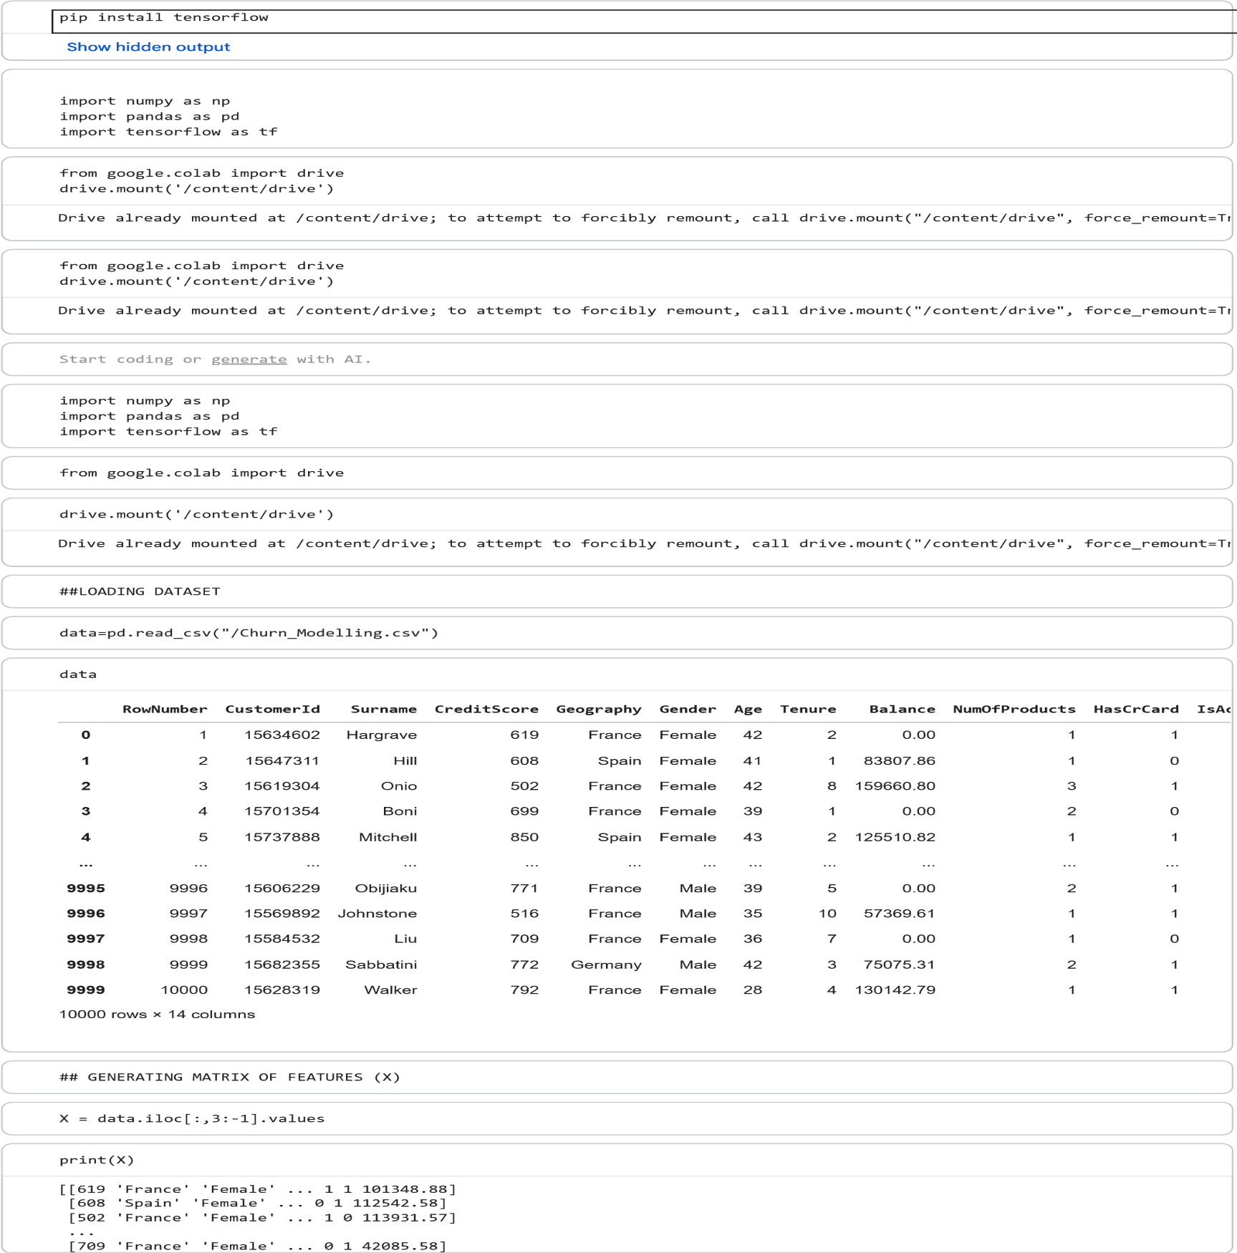
- Code Implementation:
[772 'Germany' 'Male' ... 1 0 92888.52]
[792 'France' 'Female' ... 1 0 38190.78]]
## GENERATING DEPENDENT VARIABLE VECTOR (Y)
Y = data.iloc
[:
,
-1
]
.values
print
(
Y
)
0]
[1
0 1 ... 1 1
X
,
[:
2
]
array(['Female', 'Female', 'Female', ..., 'Female', 'Male', 'Female'],

dtype=object)
## ENCODING CATEGORICAL VARIABLE GENDER
from
sklearn.preprocessing
import
LabelEncoder
LE1 = LabelEncoder
()
X
,
[:
2
]
np.array
=
(
LE1.fit_transform
(
X
,
[:
2
]))
X
[:
,
2
]
array([0, 0, 0, ..., 0, 1, 0], dtype=object)
## ENCODING CATEGORICAL VARIABLE GEOGRAPHY
ct = ColumnTransformer
(
transformers=
[(
'encoder'
,
OneHotEncoder
[
,
()
1
])]
,
remainder=
'passthrough'
)
X=np.array
(
ct.fit_transform
(
X
))
from
sklearn.compose
import
ColumnTransformer
from
sklearn.preprocessing
import
OneHotEncoder
## SPLITTING DATASET INTO TRAIN AND TEST DATASET
from
sklearn.model_selection
import
train_test_split
X_train
,
X_test
,
Y_train
,
Y_test=train_test_split
(
X
,
Y
,
test_size=
0.2
,
random_state=
0
)
from
sklearn.preprocessing
import
StandardScaler
sc = StandardScaler
()
X_train = sc.fit_transform
(
X_train
)
X_test = sc.transform
(
X_test
)
ann= tf.keras.models.Sequential
()
ann.add
(
tf.keras.layers.Dense
(
units=
6
,
activation=
'relu'
))
ann.add
(
tf.keras.layers.Dense
(
units=
6
,
activation=
'relu'
))
ann.
compile
(
optimizer=
'adam'
,
loss=
'binary_crossentropy'
,
metrics=
[
'accuracy'
])
ann.add
(
tf.keras.layers.Dense
(
units=
1
,
activation=
'sigmoid'
))
ann.fit
(
X_train
,
Y_train
,
batch_size=
32
,
epochs=
100
)
250/250
0
s
837
us/step
accuracy:
0
8612
loss:
0
3364
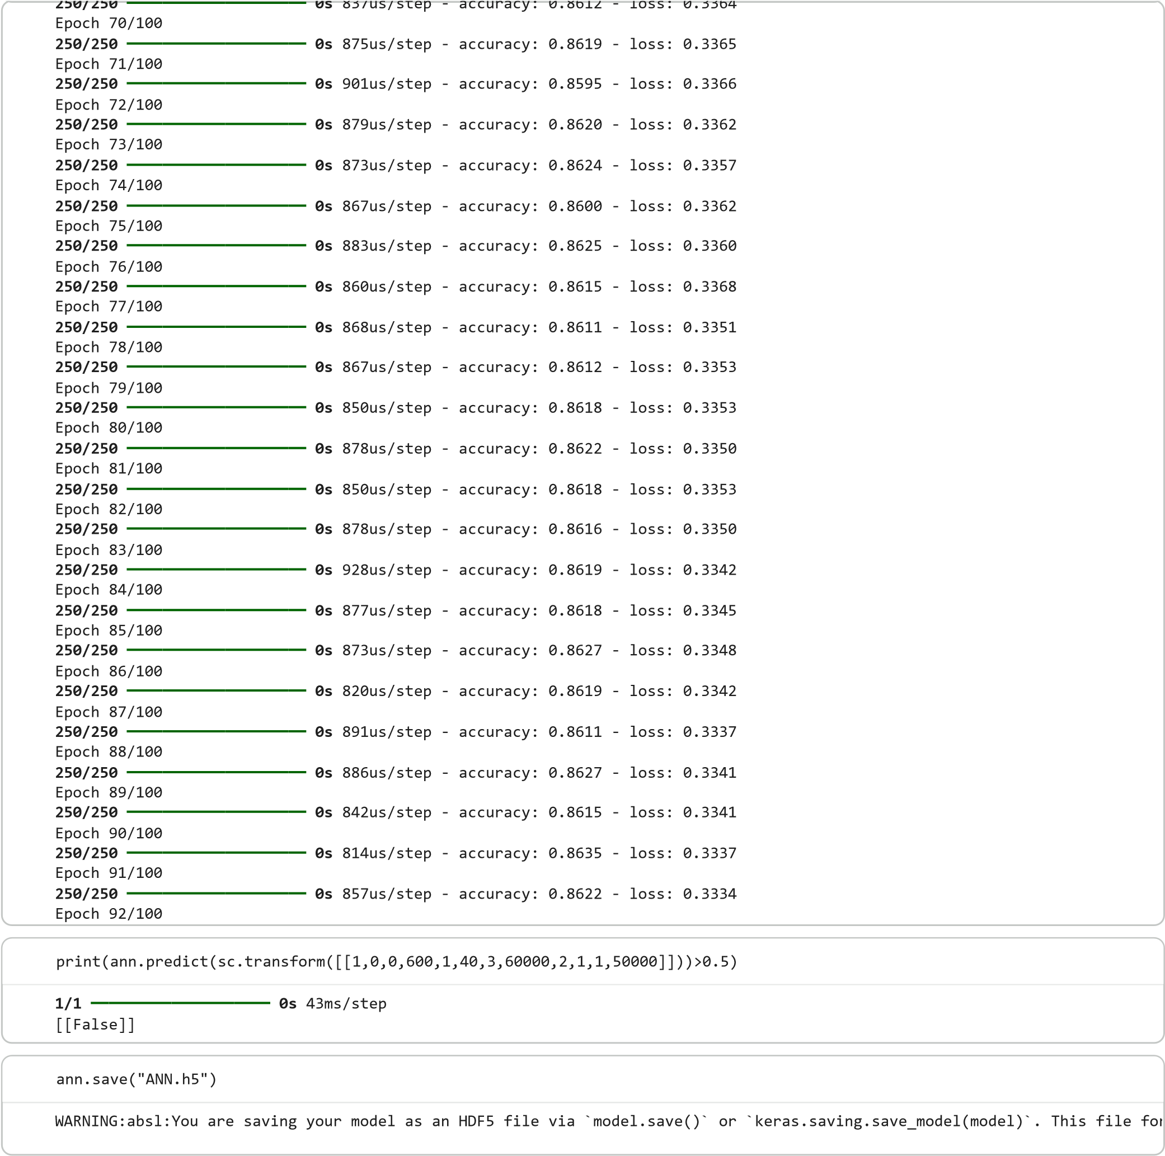

- Result:
A rudimentary multi-layer perceptron model is established with the Iris dataset, after which its evaluation score is computed.

Experiment No: 7 Optimization Using Stochastic Gradient Descent Algorithm

- Aim:
Implementing a stochastic gradient descent algorithm for optimization.

- Description:
Stochastic gradient descent (SGD) is an optimization algorithm commonly used for training machine learning models. Unlike batch gradient descent, which computes the gradient of the loss function using the entire dataset, SGD computes the gradient using a single randomly chosen data point (or a small subset of points) at each iteration. Here's how SGD works:
Initialization: Start by initializing the model parameters (weights and biases) to some random values.
Choose a Learning Rate: Select a learning rate (\ (\alpha \)), which controls the size of the step taken in the direction of the gradient.
Iterate Until Convergence: Repeat the following steps until the algorithm converges:
- Randomly shuffle the training data.
- For each data point (x^(i), y^(i)) in the training data:
- Compute the gradient of the loss function with respect to the parameters using only that data point:
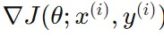
- Update the parameters using the computed gradient:
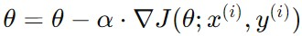
Stopping Criterion: The algorithm stops when a stopping criterion is met, such as reaching a maximum number of iterations or when the change in the parameters is below a certain threshold.

SGD is particularly useful when working with large datasets, as it can be computationally more efficient than batch gradient descent. However, it can also be more sensitive to the learning rate and may require tuning of hyperparameters to achieve good performance. In practice, a variant of SGD called mini-batch gradient descent is often used, where the gradient is computed using a small batch of data points rather than a single point. This helps to reduce the variance in parameter updates while still being more computationally efficient than batch gradient descent.
- Algorithm:
- Initialize parameters
- Define model
- Set num of iterations, penalty
- Fit the values
- Get values of weights, intercept

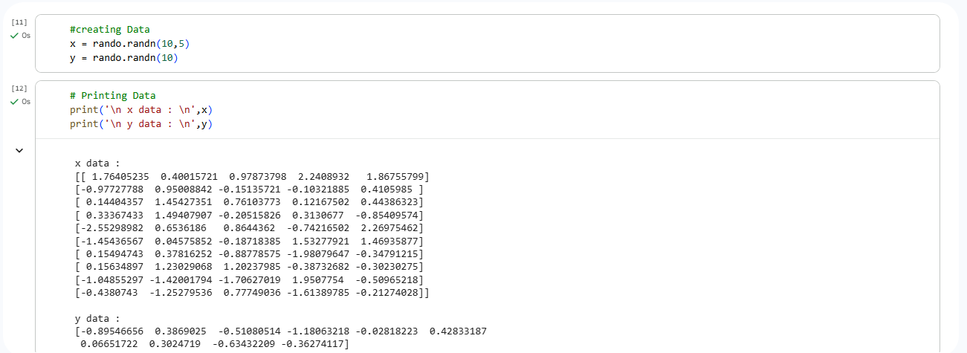

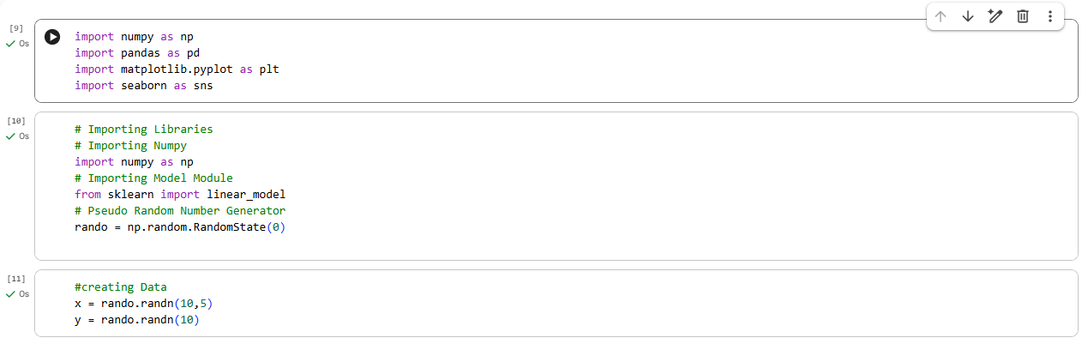
- Code Implementation:
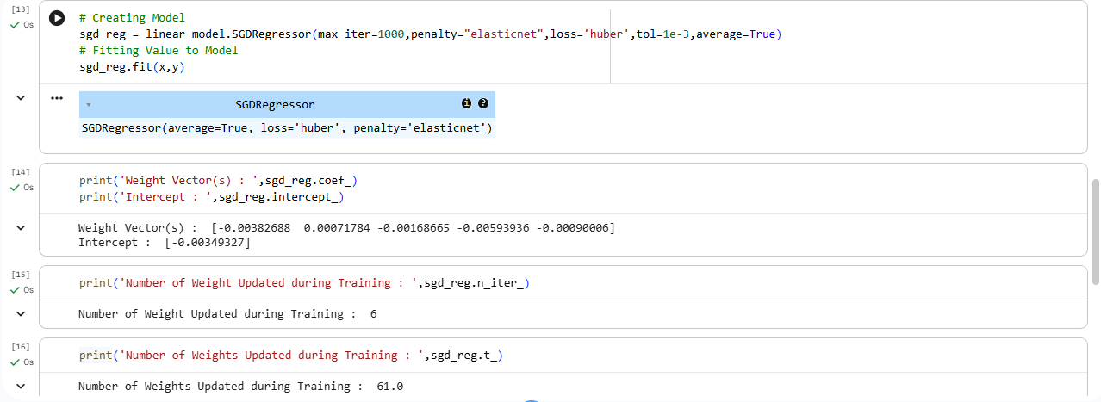

- Result:
Thus, a simple implementation of stochastic gradient descent is completed and executed.
Experiment No: 8 BUILD AN IMAGE RECOGNITION SYSTEM USING CNN

- Aim
Constructing layers from the ground up to create a CNN model for image recognition using TensorFlow 2
- Description:
CNN Model
A Convolutional Neural Network (CNN) is a type of deep learning model that is particularly effective for image recognition and classification tasks. CNNs are inspired by the organization of the animal visual cortex, and they have proven to be very successful in various computer vision tasks. Here's how CNNs work and how they are built in TensorFlow 2:
Convolutional Layer:
- The core building block of a CNN is the convolutional layer.
- Each convolutional layer applies a set of filters (also called kernels) to the input image.
- These filters detect different features of the input, such as edges, textures, and shapes. - The output of a convolutional layer is a set of feature maps, each representing the result of applying one filter to the input image.
Activation Function:
- After each convolution operation, an activation function like ReLU (Rectified Linear Unit) is applied element-wise to introduce non-linearity into the network.
Pooling Layers:
- Pooling layers are used to down sample the feature maps, reducing their spatial dimensions.
- Common pooling operations include max pooling and average pooling, which take the maximum or average value over a small region of the feature map, respectively.
Flattening:
- After several convolution and pooling layers, the remaining feature maps are flattened into a one-dimensional vector.

Fully Connected Layers:
- The flattened vector is passed through one or more fully connected layers, which perform classification based on the learned features.
- The last fully connected layer typically has nodes corresponding to the number of classes in the classification task.
Output Layer:
- The final layer produces the output of the network, representing the predicted class probabilities for classification tasks.
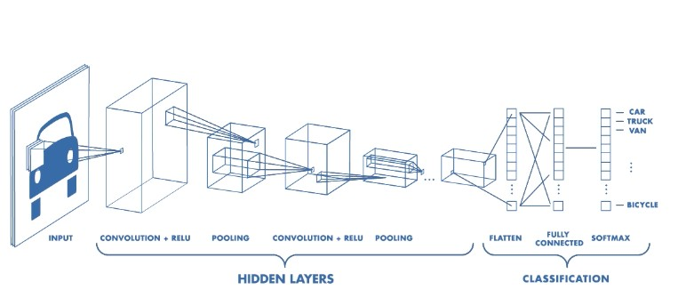
Image Source: https://www.mathworks.com/videos/introduction-to-deep-learningwhat-are convolutional-neural-networks--1489512765771.html

Algorithm
- Import dataset
- Create the network model architecture
- Build the layers and compile the model
- Fit the values and train with set number of epochs and in batch.
- Predict the outcome using test data
- Check the performance metrics of the model

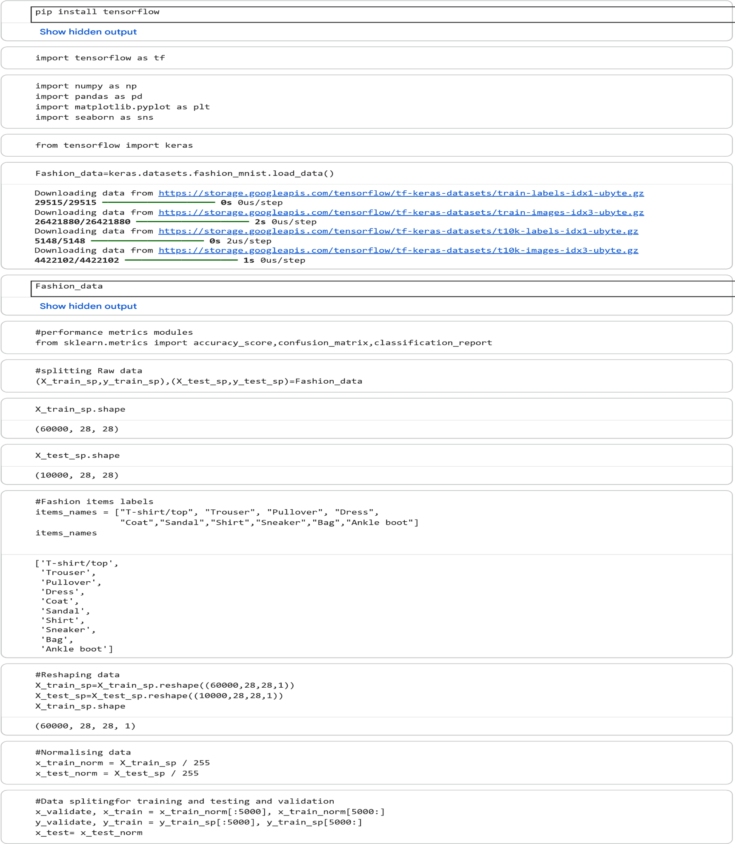
Code Implementation:
y_train.shape
(55000,)
/usr/local/lib/python3.12/dist-packages/keras/src/layers/convolutional/base_conv.py:113: UserWarning: Do not pass an `input_
super().__init__(activity_regularizer=activity_regularizer, **kwargs)
Model: "sequential"
┏━━━━━━━━━━━━━━━━━━━━━━━━━━━━━━━━━┳━━━━━━━━━━━━━━━━━━━━━━━━┳━━━━━━━━━━━━━━━┓
┃
Layer (type)
┃
Output Shape
┃
Param #
┃
┡━━━━━━━━━━━━━━━━━━━━━━━━━━━━━━━━━╇━━━━━━━━━━━━━━━━━━━━━━━━╇━━━━━━━━━━━━━━━┩
│ conv2d (
Conv2D
(
│
)
None
,
26
,
26
,
32
)
│
320
│
├─────────────────────────────────┼────────────────────────┼───────────────┤
│ max_pooling2d (
MaxPooling2D
(
│
)
None
,
13
,
13
,
32
)
│
0
│
├─────────────────────────────────┼────────────────────────┼───────────────┤
│ flatten (
Flatten
(
│
)
None
,
5408
│
)
0
│
├─────────────────────────────────┼────────────────────────┼───────────────┤
│ dense (
Dense
)
│
(
None
,
300
)
│
1,622,700
│
├─────────────────────────────────┼────────────────────────┼───────────────┤
│ dense_1 (
Dense
)
│
(
None
,
100
)
│
30,100
│
├─────────────────────────────────┼────────────────────────┼───────────────┤
│ dense_2 (
Dense
│
(
)
None
,
10
│
)
1,010
│
└─────────────────────────────────┴────────────────────────┴───────────────┘
Total params:
1,654,130
(6.31 MB)
Trainable params:
1,654,130
(6.31 MB)
Non-trainable params:
0
(0.00 B)
#Random seed
tf.random.set_seed(
42
)
#Model Architecture
model=keras.models.Sequential()
#Building model
model.add(keras.layers.Conv2D(filters=
32
,kernel_size=(
3
,
3
,strides
)
=(
1
,
1
=
,padding
)
'valid'
,activation=
'relu'
,input_shape=(
28
,
model.add(keras.layers.MaxPooling2D(pool_size=(
2
,
2
)))
model.add(keras.layers.Flatten())
model.add(keras.layers.Dense(
300
,activation=
'relu'
))
model.add(keras.layers.Dense(
100
,activation=
'relu'
))
model.add(keras.layers.Dense(
10
,activation=
'softmax'
))
#Model Summary
model.summary()
# Compiling the model
model.
compile
(
loss
=
"sparse_categorical_crossentropy"
, optimizer=
"sgd"
,
metrics=[
"accuracy"
])
# Fitting Values to Model
model_fit = model.fit(x_train, y_train, epochs=
5
, batch_size=
64
,
validation_data=(x_validate,
y_validate))
# Model Performance Visualization
pd.DataFrame(model_fit.history).plot(figsize=(
8
,
5
))
plt.title(
'Model Performance'
)
plt.xlabel(
'Epochs'
)
plt.ylabel(
'Performance'
)
plt.grid(
True
)
plt.show()
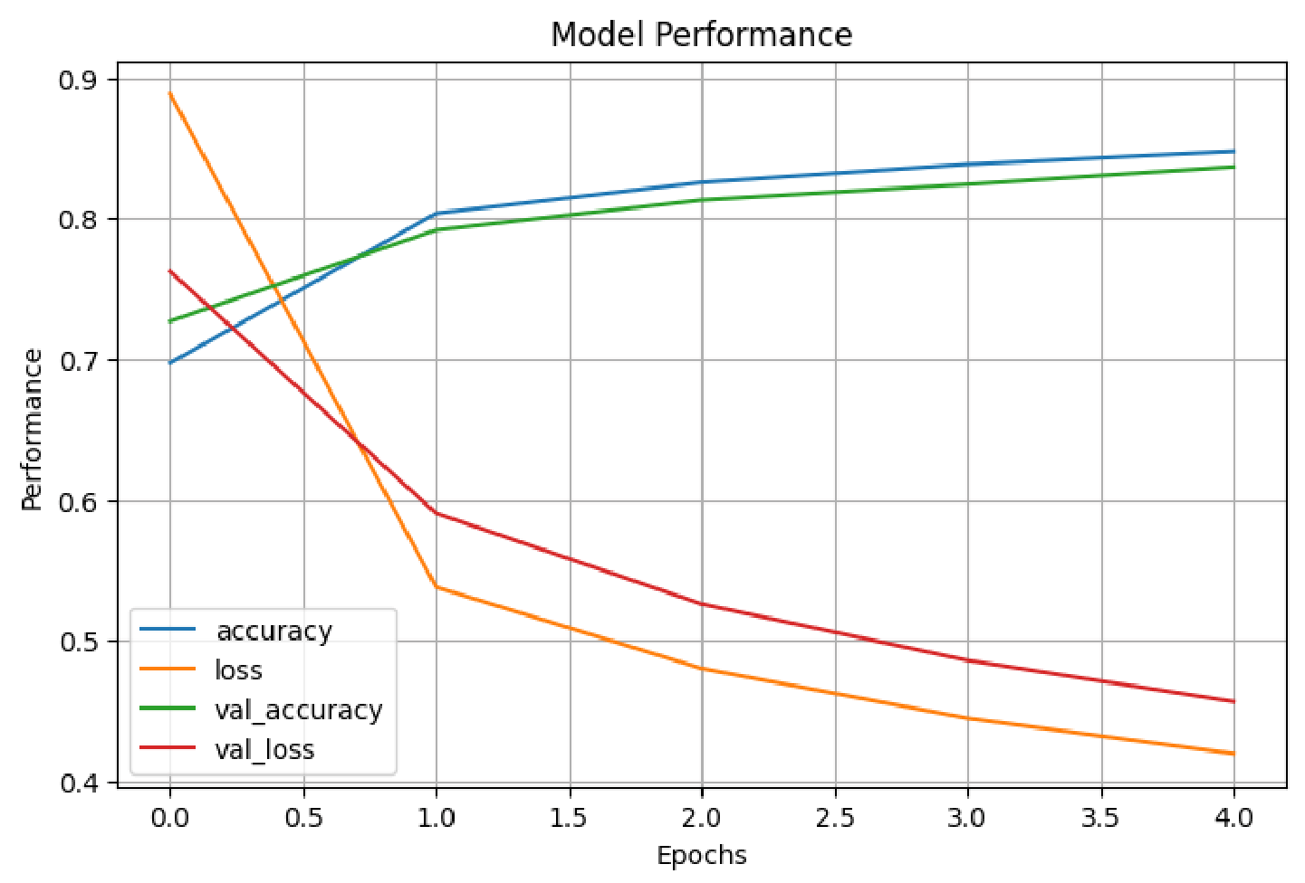
Epoch 1/5
860/860

━━━━━━━━━━━━━━━━━━━━

48
s
53ms/step - accuracy: 0.6972 - loss: 0.8887 - val_accuracy: 0.7270 - val_loss: 0.7624
Epoch 2/5
860/860

━━━━━━━━━━━━━━━━━━━━

s
74
44ms/step - accuracy: 0.8037 - loss: 0.5378 - val_accuracy: 0.7918 - val_loss: 0.5904
Epoch 3/5
860/860

━━━━━━━━━━━━━━━━━━━━

38
s
44ms/step - accuracy: 0.8258 - loss: 0.4799 - val_accuracy: 0.8132 - val_loss: 0.5258
Epoch 4/5
860/860

━━━━━━━━━━━━━━━━━━━━

38
s
44ms/step - accuracy: 0.8386 - loss: 0.4445 - val_accuracy: 0.8244 - val_loss: 0.4857
Epoch 5/5
860/860

━━━━━━━━━━━━━━━━━━━━

41
s
45ms/step - accuracy: 0.8478 - loss: 0.4194 - val_accuracy: 0.8368 - val_loss: 0.4564
# Model Evaluation
score = model.evaluate(x_test, y_test_sp)
print
(
'Model Evaluation Score :'
, score)
# Prediction & Class Output
y_pred = np.argmax(model.predict(x_test), axis=
-1
)
print
(
'y_pred output :'
, y_pred)
# Class & Labels of initial 3 data
print
(
'Predicted Class : '
, y_pred[:
3
])
print
(
'Predicted Class in Labels : '
, np.array(items_names)[y_pred[:
3
]])
# Predicted Output Visualization
plt.figure(figsize=(
6
,
4
))
plt.imshow(x_test[
80
]
.reshape
((
28
,
28
)))
plt.show()
# Performance Metrics
# Confusion Matrix
print
(
'Confusion Matrix : \n'
, confusion_matrix(y_test_sp, y_pred))
# Accuracy Score
print
(
'Accuracy Score : '
, accuracy_score(y_test_sp, y_pred))
# Classification Report
print
(
'Classification Report : \n'
, classification_report(y_test_sp, y_pred))
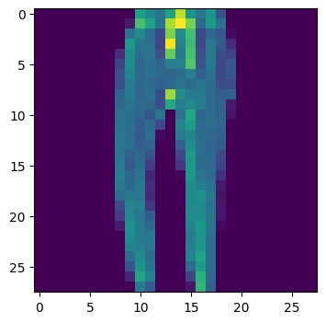
313/313

━━━━━━━━━━━━━━━━━━━━

3
s
9ms/step - accuracy: 0.8091 - loss: 0.5099
Model Evaluation Score : [0.5099225640296936, 0.8090999722480774]
313/313

━━━━━━━━━━━━━━━━━━━━

3
s
8ms/step
y_pred output : [9 2 1 ... 8 1 5]
Predicted Class : [9 2 1]
Predicted Class in Labels : ['Ankle boot' 'Pullover' 'Trouser']
Confusion Matrix :
[[532 2 54 44 26 2 326 0 14 0]
[ 0 952 2 30 11 0 4 0 1 0]
[ 3 1 720 6 247 1 19 0 3 0]
[ 2 15 28 766 129 0 56 0 4 0]
[ 0 0 53 6 923 0 14 0 4 0]

- Result:
Therefore, the CNN model with its individual layers has been successfully created and tested for image recognition. This was achieved by training the model using a dataset and obtaining performance metrics for the model.
Experiment No: 9 Stock Price Prediction Using LSTM

- Aim:
Construct the LSTM model using layers to predict stock prices.
- Description:
LSTM Model
Long Short-Term Memory (LSTM) is a type of recurrent neural network (RNN) architecture designed to capture long-term dependencies in sequential data. It is particularly effective for tasks such as natural language processing (NLP), speech recognition, and time series forecasting. Here's how LSTM works and how it can be implemented in TensorFlow 2:
Cell State and Gates:
- The key to LSTM's ability to capture long-term dependencies is its cell state, which serves as a conveyor belt that can run along the entire sequence, with only minor linear interactions.
- LSTM has three gates that control the flow of information into and out of the cell state:
- Forget Gate: Determines which information to discard from the cell state.
- Input Gate: Determines which new information to store in the cell state.
- Output Gate: Determines which information to output based on the cell state.
LSTM Operations:
- At each time step, the LSTM takes as input the current input xt, the previous hidden state h(t-1), and the previous cell state c(t-1).
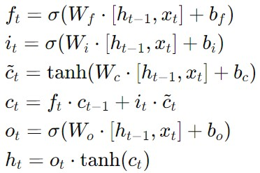
- It then computes the new cell state ct and the new hidden state ht using the following equations:

Here, ft, it, and ot are the forget, input, and output gate vectors, respectively. tilde{c}t is the candidate cell state vector, and ct is the new cell state. sigma is the sigmoid activation function, and tanh is the hyperbolic tangent activation function.

Algorithm
- Import dataset
- Feature scale the data if needed
- Create the network model architecture
- Build the layers and compile the model
- Fit the values and train with set number of epochs and in batch.
- Predict the outcome using test data.

Code Implementation: 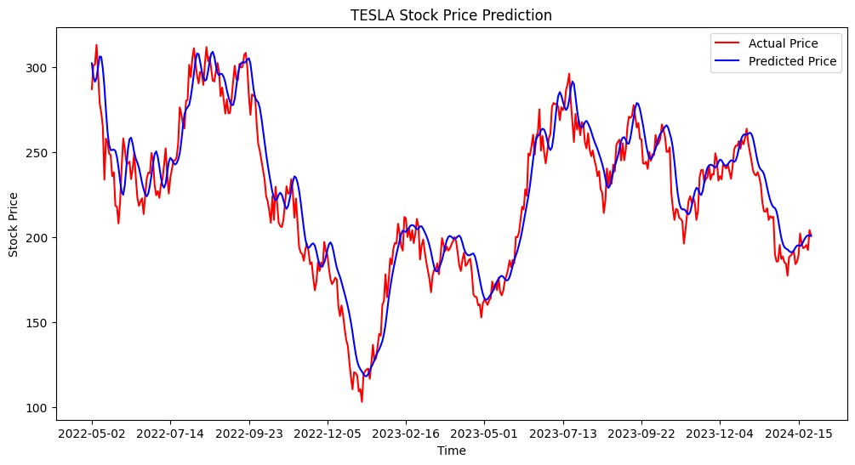
# Importing Libraries
# Numpy and Pandas
import
numpy
as
np
import
pandas
as
pd
# Data Visualization
import
matplotlib.pyplot
as
plt
# Pre-Processing Module
from
sklearn.preprocessing
import
MinMaxScaler
# Keras Modules
from
keras.models
import
Sequential
from
keras.layers
import
*
from
keras.layers
import
LSTM, Dropout
# Importing dataset
tesla = pd.read_csv
(
"
/content/Tesla.csv
"
)
# Printing dataset
print
(
tesla
)
Show hidden output
# Data Splitting
training = tesla.iloc[:
800
,
1
:
2
]
.values
testing = tesla.iloc[
800
,
:
1
:
2
.values
]
# Data Normalization
mm_scale = MinMaxScaler(feature_range=(
0
,
1
))
training_scaled = mm_scale.fit_transform(training)
# Data structure with 60 time steps and 1 output
x_train = []
y_train = []
for
i
in

range
(
60
,
800
):
x_train.append(training_scaled[i
-60
:
i,
0
])
y_train.append(training_scaled[i,
0
])
x_train, y_train = np.array(x_train), np.array(y_t
rain)
x_train = np.reshape(x_train, (x_train.shape[
0
]
, x_train.shape
[
1
]
,
1
))
# Model Architecture
model = Sequential()
# Building Model
model.add(LSTM(units=
50
, return_sequences=
True
, input_shape=(x_train.shape[
1
]
,
1
)))
model.add(Dropout(
0.2
))
model.add(LSTM(units=
50
, return_sequences=
True
))
model.add(Dropout(
0.2
))
model.add(LSTM(units=
50
, return_sequences=
True
))
model.add(Dropout(
0.2
))
model.add(LSTM(units=
50
))
model.add(Dropout(
0.2
))
model.add(Dense(units=
1
))
/usr/local/lib/python3.12/dist-packages/keras/src/layers/rnn/rnn.py:199: UserWarning: Do not pass an `in
super().__init__(**kwargs)
# Compiling the model
model.
compile
(
optimizer
=
'adam'
, loss=
'mean_squared_error'
)
# Fitting values to model
model.fit
(
x_train, y_train, epochs=
100
, batch_size=
32
)
Show hidden output
# Preparing Test Data
train_data = tesla.iloc[:
800
,
1
:
2
]
test_data = tesla.iloc[
800
,
:
1
:
2
]
total_data = pd.concat((train_data, test_data), ax
is=
0
)
inputs = total_data[
len
(
total_data) -
len
test_data) -
(
60
.values
:]
inputs = inputs.reshape(
-1
,
1
)
inputs = mm_scale.transform(inputs)
x_test = []
for
i
in

range
(
60
,
519
):
x_test.append(inputs[i
-60
i,
:
0
])
x_test = np.array(x_test)
x_test = np.reshape(x_test, (x_test.shape[
0
, x_test.shape
]
[
1
,
]
1
))
# Prediction
stock_price_predicted = model.predict(x_test)
stock_price_predicted = mm_scale.inverse_transform
(
stock_price_predicted
)
15
/
15

━━━━━━━━━━━━━━━━━━━━

1
s
54ms/step
# Visualization
plt.figure(figsize=(
12
,
6
))
plt.plot(tesla.loc[
800
,
:
"Date"
, test_data.values, color
=
]
"red"
, label=
"Actual Price"
)
plt.plot(tesla.loc[
800
:
,
"Date"
]
, stock_price_predicted, color
=
"blue"
, label=
"Predicted Price"
)
plt.xticks(np.arange(
0
,
459
,
50
))
plt.title(
'TESLA Stock Price Prediction'
)
plt.xlabel(
'Time'
)
plt.ylabel(
'Stock Price'
)
plt.legend()
plt.show()
Start coding or
g
enerate
with AI.
5
/15/26, 10:51 AM
tesla.ipynb - Colab

RESULT:
Thus, the LSTM model generated predicts the stock price based on the provided data.

Experiment No: 10 Neural Style Transfer Using Gan

- Aim:
Applying a style from one image to another using neural style transfer with Generative Adversarial Networks (GANs).
- Description:
Neural Style Transfer:
Neural style transfer is a technique in deep learning that combines the content of one image with the style of another image to create a new image. This technique is based on the idea that the content of an image can be separated from its style, and these two aspects can be independently manipulated.
Content Image and Style Image:
- Neural style transfer requires two input images: a content image and a style image. - The content image is the image whose content (objects and their arrangement) we want to preserve in the final image.
- The style image is the image whose style (textures, colors, and brush strokes) we want to apply to the final image.
Feature Extraction:
- Neural style transfer typically uses a pre-trained convolutional neural network (CNN) to extract features from the content and style images.
- The CNN is used to extract features at different layers of the network, capturing both low-level features (e.g., edges and textures) and high-level features (e.g., objects and their arrangements).
Loss Functions:
- Neural style transfer uses three loss functions to define the optimization problem: - Content Loss: Measures the difference between the content features of the generated image and the content image. It ensures that the generated image preserves the content of the content image.
- Style Loss: Measures the difference between the style features of the generated image and the style image. It ensures that the generated image has a similar style to the style image.
- Total Variation Loss: Encourages smoothness in the generated image by penalizing rapid changes in pixel values.
Optimization:
- Neural style transfer aims to minimize the total loss, which is a weighted sum of the content loss, style loss, and total variation loss.
- The optimization process involves updating the pixel values of the generated image to minimize the total loss using gradient descent or a similar optimization algorithm.
Output Image:
- The output of the neural style transfer algorithm is a new image that combines the content of the content image with the style of the style image.
- The generated image preserves the content and structure of the content image while incorporating the colors, textures, and brush strokes of the style image.

Neural style transfer is a powerful technique that can be used for artistic purposes, such as creating stylized images or videos, as well as for practical applications, such as image editing and content generation.

Image Source - https://chelseatroy.com/2019/03/01/neural-style-transfer-with-latteart-part-1-layer-depth/

Algorithm
- Import original image
- Check the size, shape, color channel and tensor shape
- Import Style image and perform the same set of checks
- Display and check the actual images
- For the model connect to the TF-Hub handle
- To the model now provide the original and style image
- Finally display the styled image

Code Implementation:
Neural Style Transfer
 Importing Libraries
pip install tensorflow
Show hidden output
pip install tensorflow-hub
Show hidden output
from
matplotlib
import
gridspec
import
matplotlib.pylab
as
plt
import
numpy
as
np
import
tensorflow
as
tf
import
tensorflow_hub
as
tf_hub
import
PIL
from
google.colab
import
files
 Image Processing Function
upload=files.upload()
def

load_image
(
image
,
image_size
=(
512
,
512
)):
img = tf.io.read_file(image)
img = tf.image.decode_image(img, channels=
3
)
img = tf.image.convert_image_dtype(img, tf.float
32)
img = tf.image.resize(img, image_size, preserve_
aspect_ratio=
True
)
img = img[tf.newaxis, :]

return
img
 Uploading Original Image
Choose Files
content.png
content.png
image/png) - 2944741 bytes, last modified: 5/13/2026 -
(
100
% done
Saving content.png to content (2).png
upload = files.upload()
original_image = load_image(
"content (2).png"
)
from
google.colab
import
drive
drive.mount(
'/content/drive'
)
Mounted at /content/drive
original_image.shape
TensorShape([1, 410, 512, 3])
 Upload Style Image
Choose Files
style.png
style.png
(
image/png) - 3557801 bytes, last modified: 5/13/2026 -
100
% done
Saving style.png to style (2).png
Style_image = load_image(
"style (2).png"
)
Style_image.shape
TensorShape([1, 512, 512, 3])
 Display Function
def

imshow
(
image
,
title
=
None
):

if

len
(
image.shape) >
3
:
image = tf.squeeze(image, axis=
0
)
plt.imshow(image)

if
title:
plt.title(title)
 Displaying Images
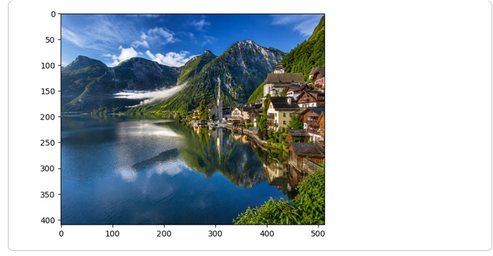
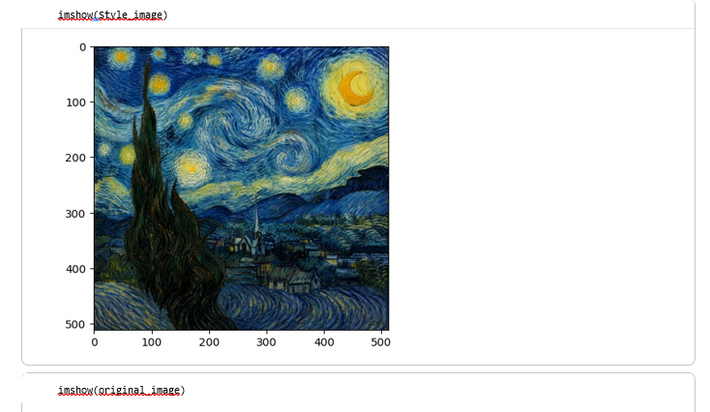
hub_handle =
'https://tfhub.dev/google/magenta/arbitrary-image-
stylization-v1-256/2'
 Hub Module
hub_module = tf_hub.load(hub_handle)
 Neural Style Transfer
outputs = hub_module(Style_image,original_image)
outputs
Show hidden output
 Displaying Styled Image
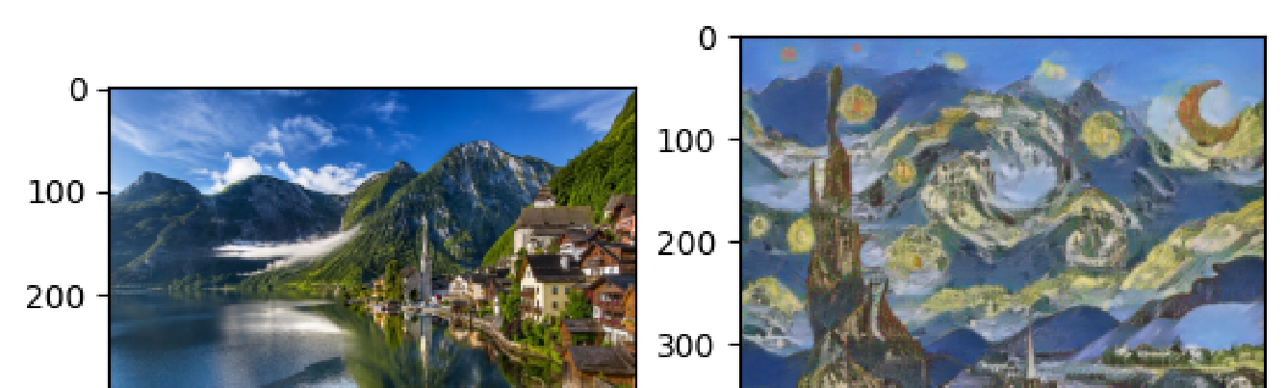
plt.subplot(
1
,
2
,
1
)
imshow(original_image)
plt.subplot(
1
,
2
,
2
)
imshow(outputs[
0
])

RESULT:
Therefore, the styled image result is achieved through the utilization of neural style transfer with GANs

